
Gr

System Design & ImplementationProject Title: FarmFusion - Smart Agro-Diary Eco System
Only for course Teacher
 |  | Needs Improvement | Developing | Sufficient | Above Average | Total Mark
Allocate mark & Percentage |  | 25% | 50% | 75% | 100% | 20
UML Design Completeness | 8
UML Design Correctness | 7
Implementation Quality & Functionality | 5
Total obtained mark
Comments

Semester: Summer 2026 Group: 04
Name | ID | Batch | Section
Md Sakib Hossain | 242-35-239 | 43 | F1
Md Bayezid Mukabbir | 242-35-041 | 43 | F1
Sheikh Saymon Mahmud | 242-35-477 | 43 | F1
Md Jahid Haider Helale | 242-35-084 | 43 | F1

Course Code: SE231
Course Name: System Analysis & Design Capstone Project
Course Teacher Name: Md. Selim Reza
Designation: Assistant Professor Submission Date: 08/06/2026

Use Case Diagram:
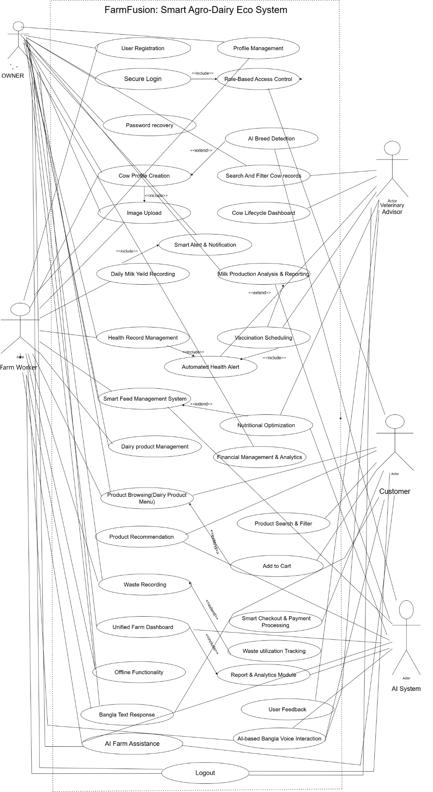

Activity Diagram:

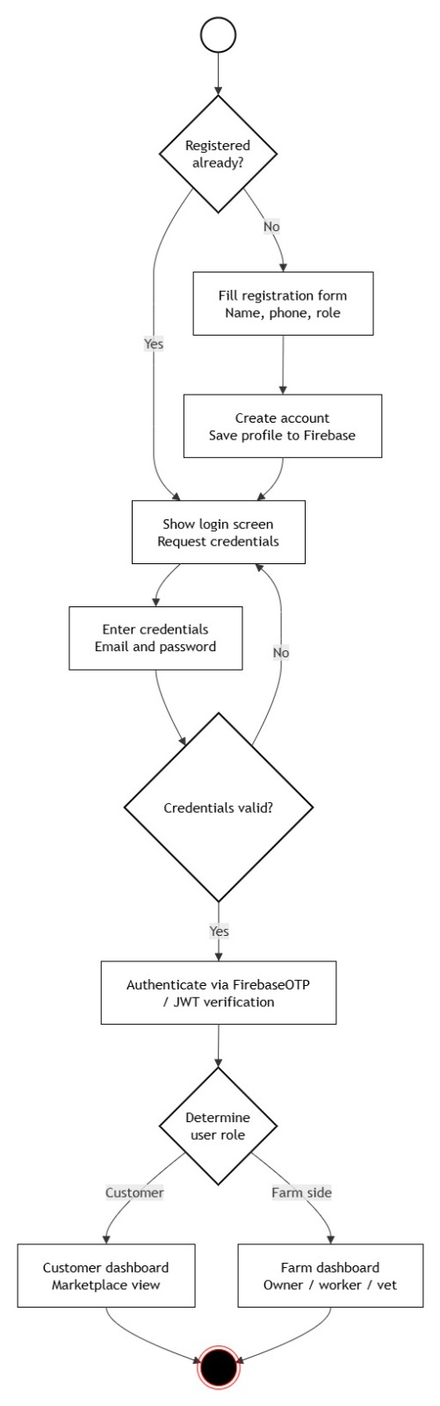
1.User Authentication (Login/Registration)

2. Milk Production & Analytics

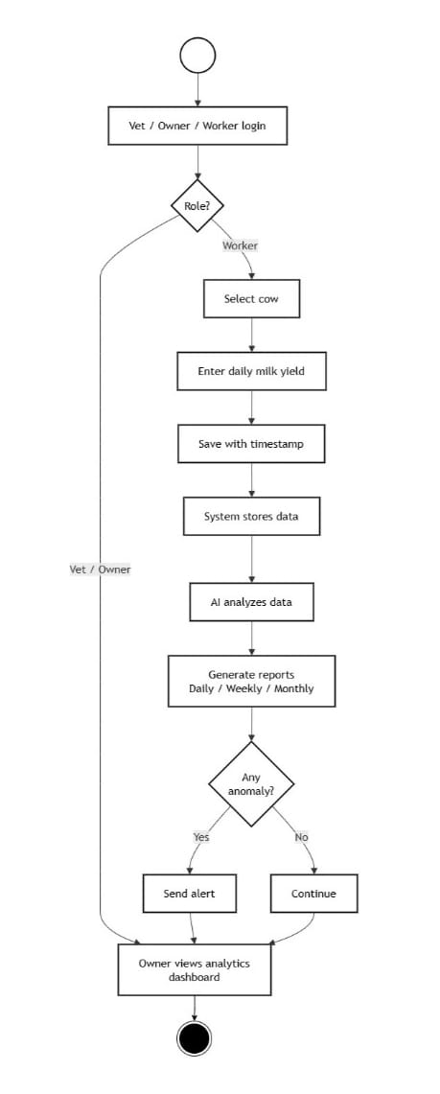
3 . Health & Vaccination Management
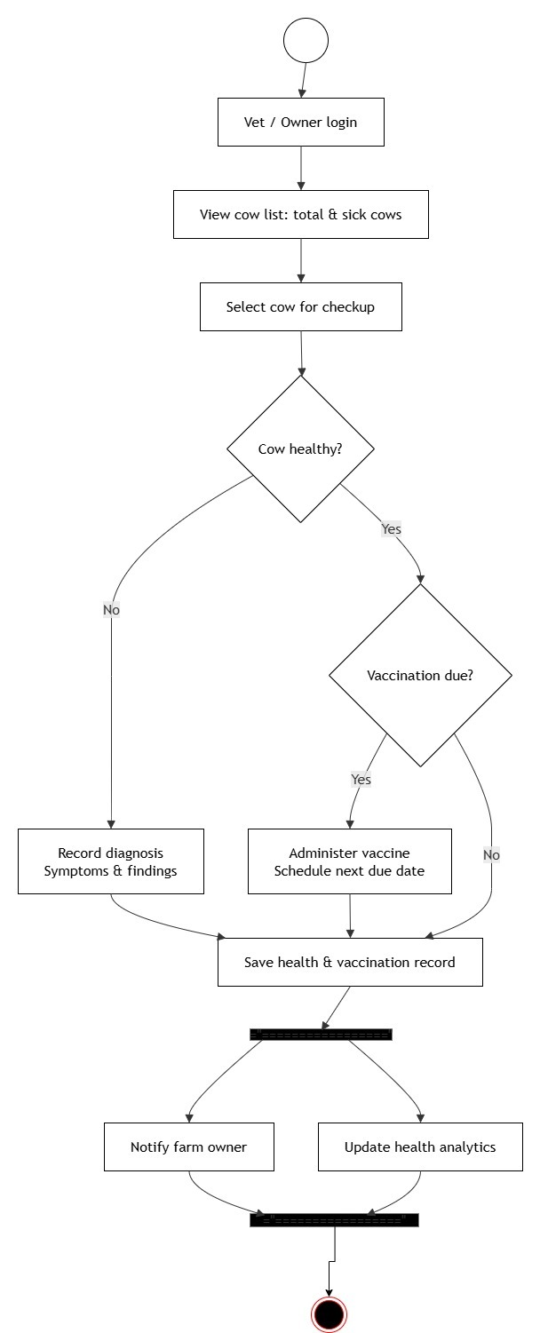
ER Diagram:

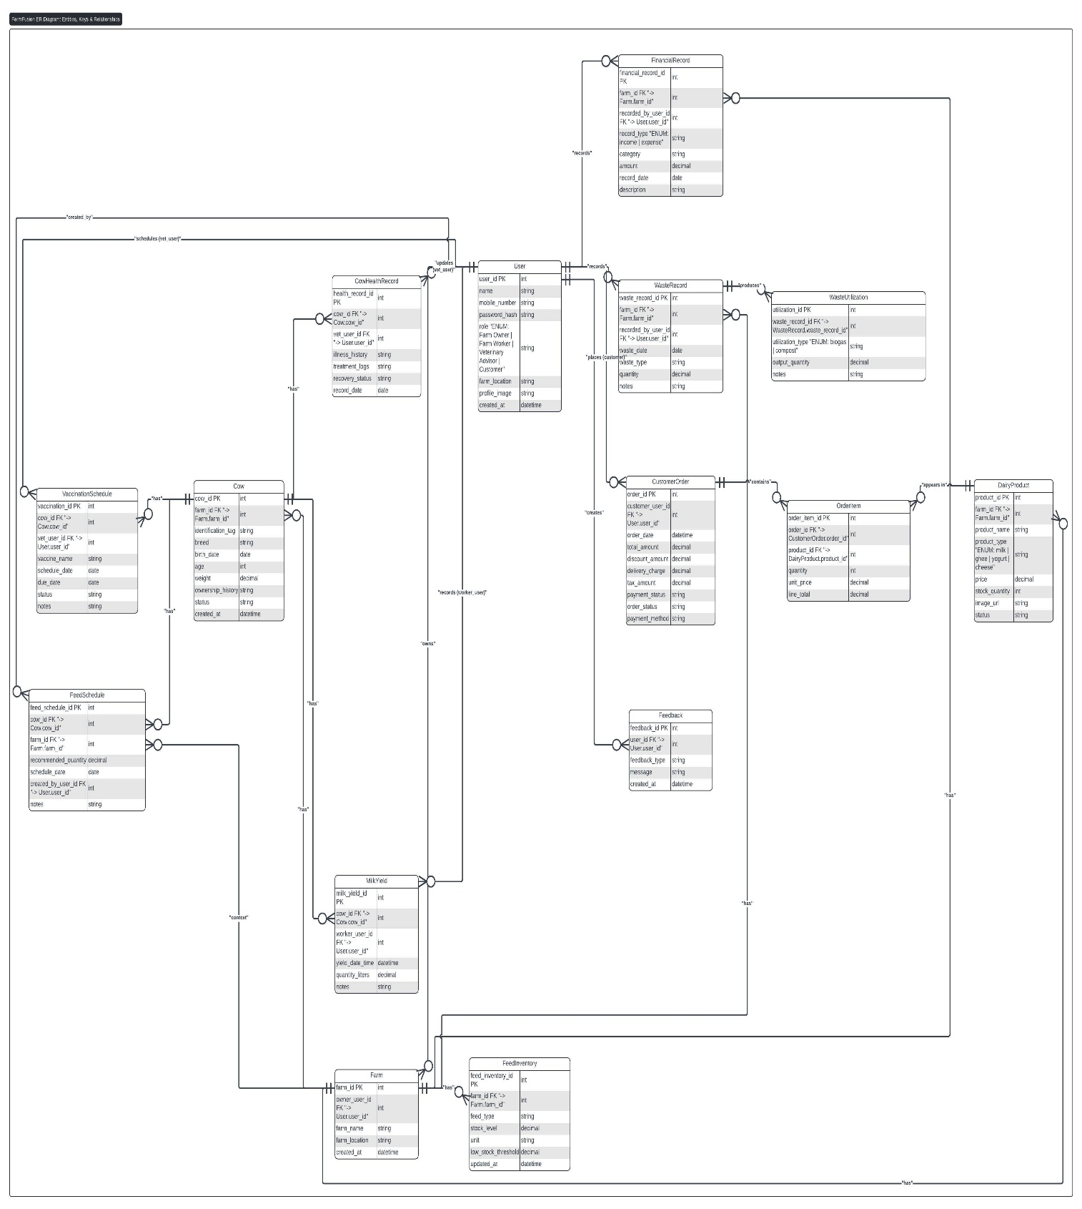
UML class Diagram:

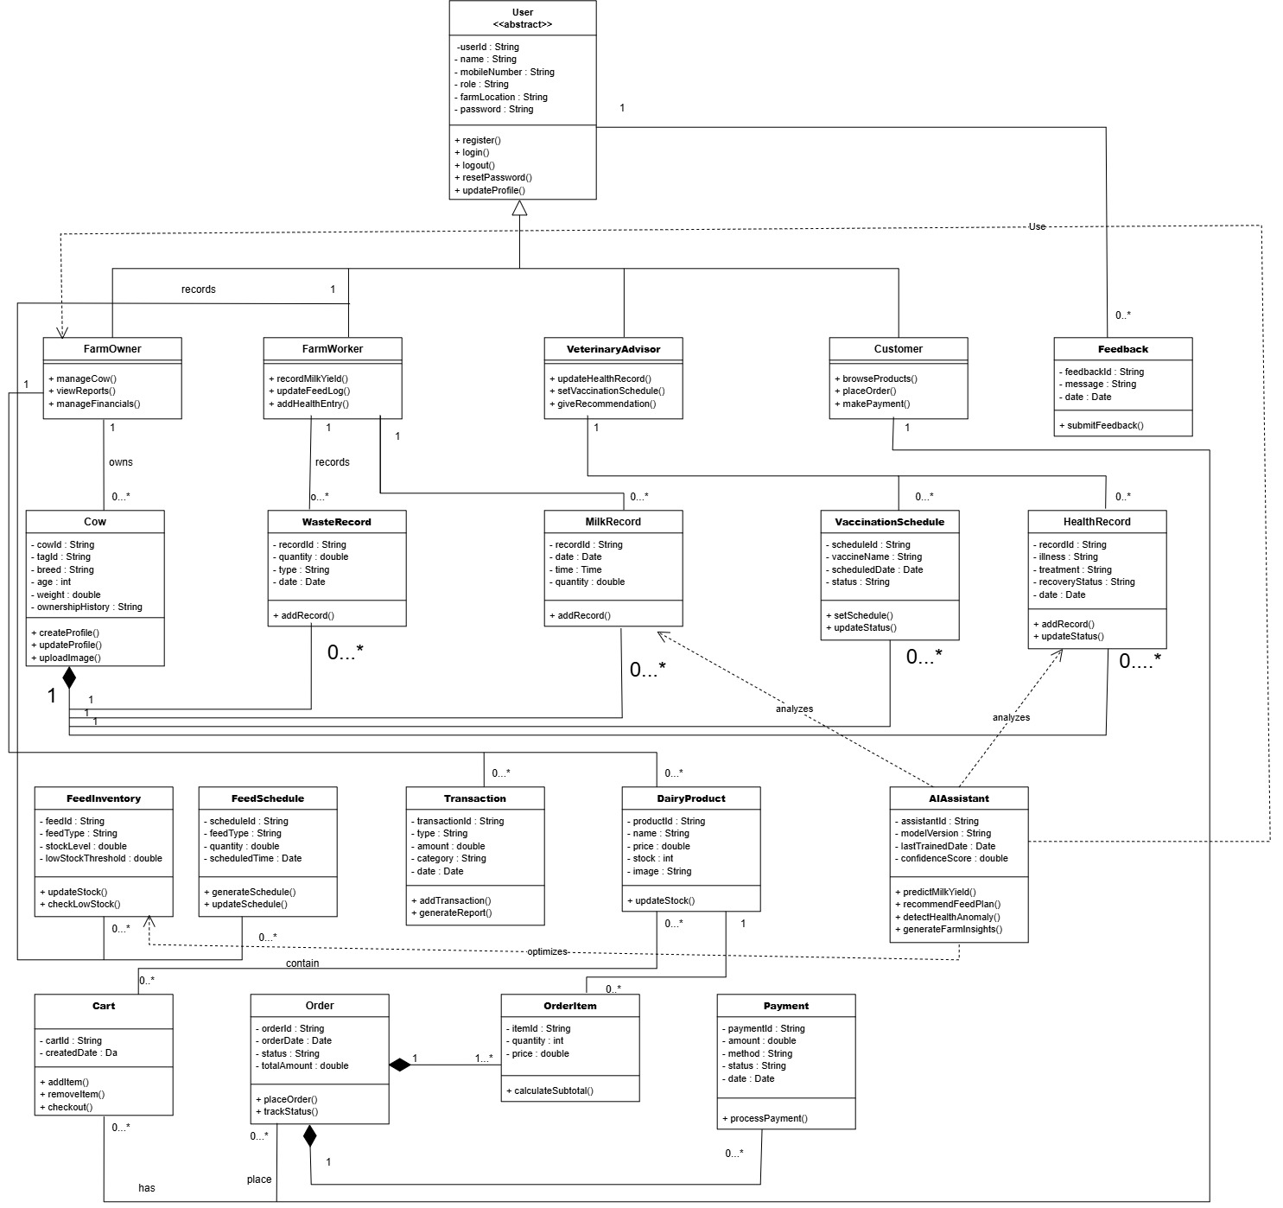
Sequence Diagram:
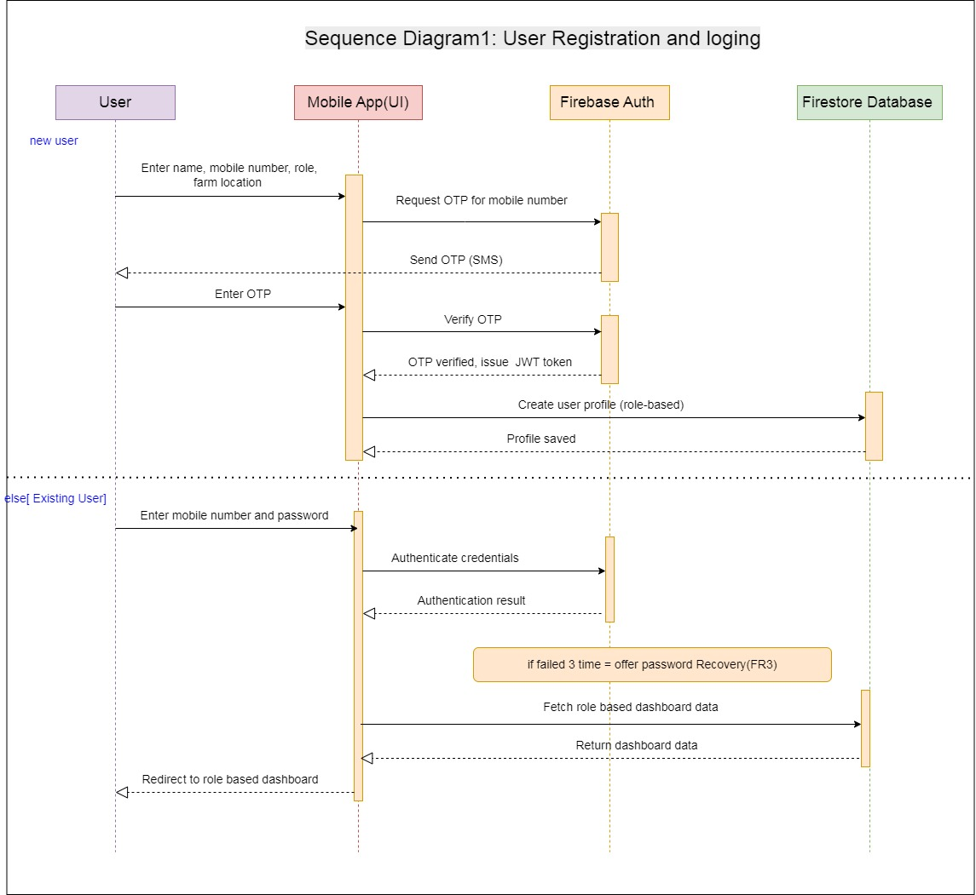

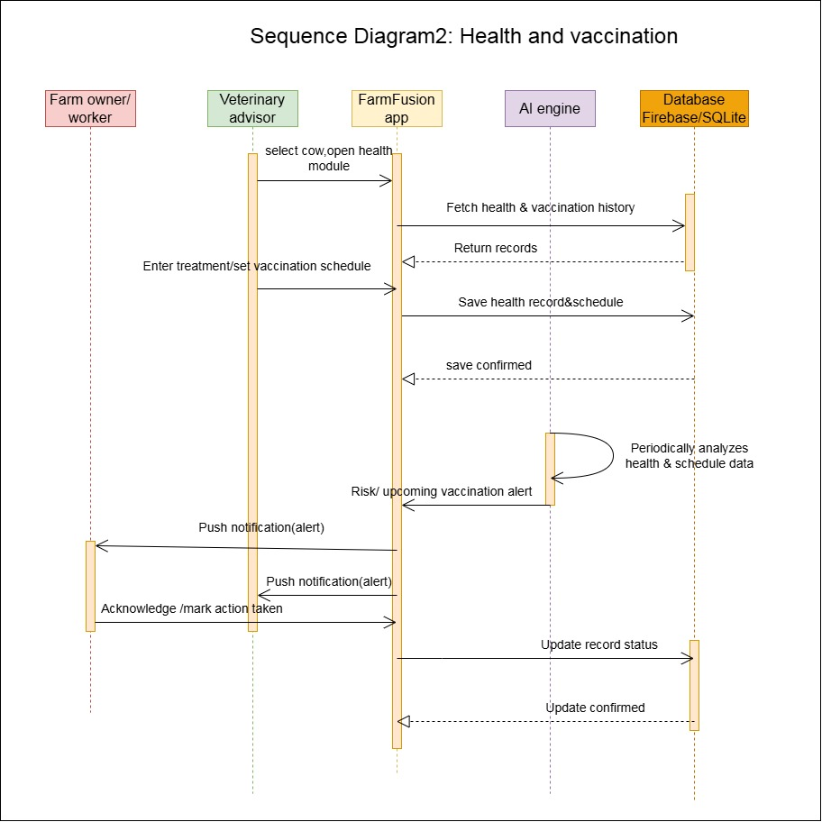
Sequence Diagram 3: Diary product management
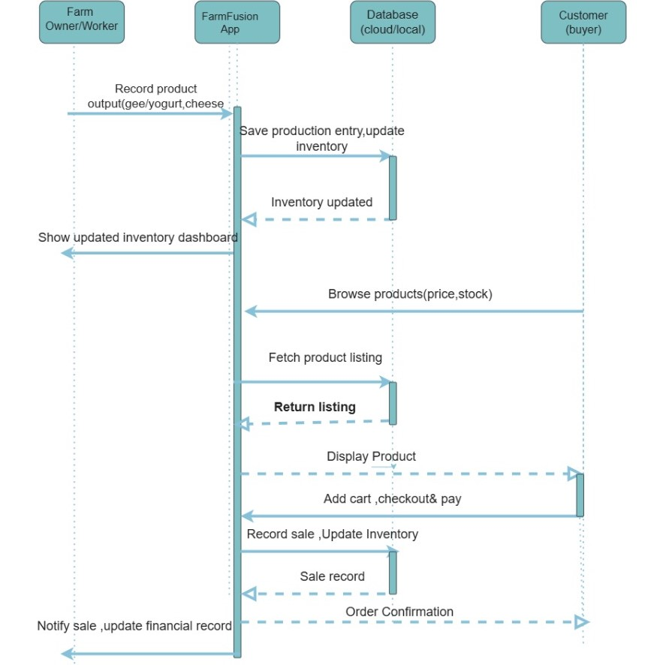

Sequence diagram 4: milk record
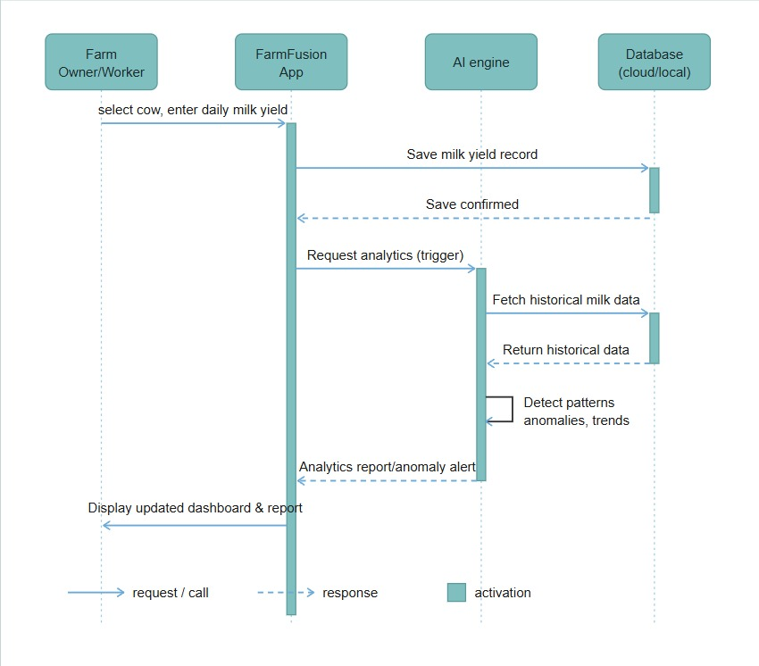

DFD (Data Flow Diagram)

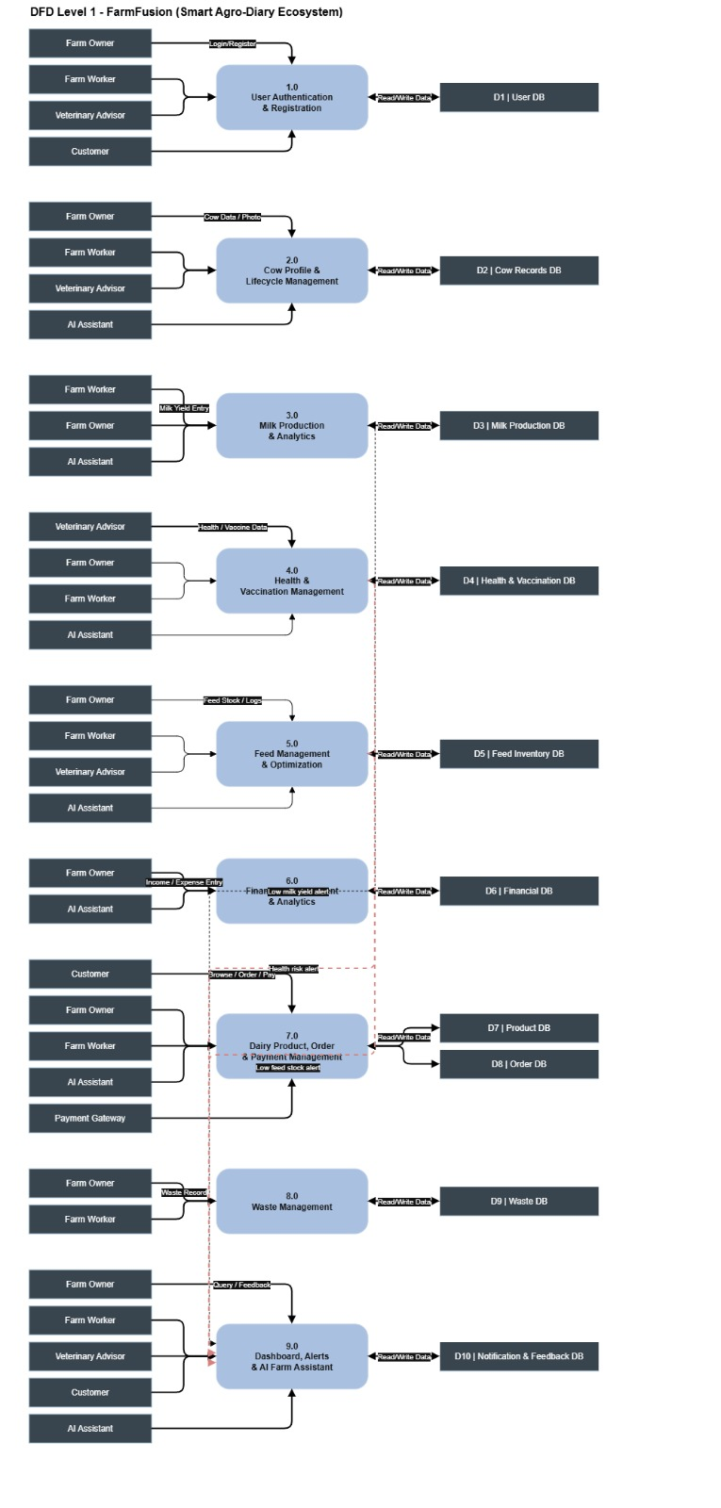

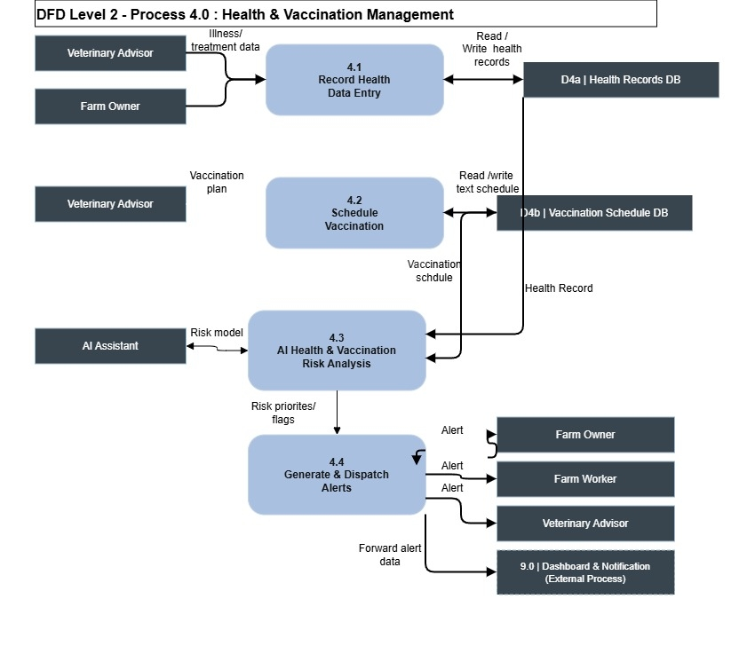
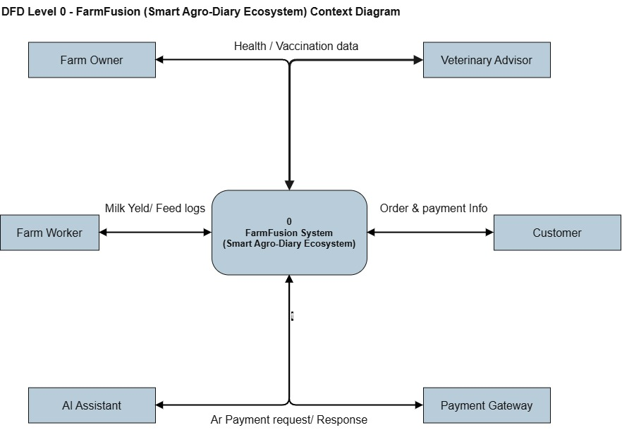

Pototype design

